
NATIONAL KEY POINT SECURITY TRAINING
LEARNER GUIDE
Explain the requirements for safeguarding a National Key Point
SAQA UNIT STANDARD 246693 | NQF LEVEL 4 | 4 CREDITS
Document code: MTC-NKP-LG-01 | Advanced Blended Edition 4.1 | 19 August 2026
Status: Expanded training draft - subject to legal, accreditation and subject-matter approval
377 Johannes Ramakhoase Street, Office 0005, Jardown 1
+27 12 004 2004 | WhatsApp +27 84 750 7013
admin@mupotrainingcenter.co.za | www.mupotrainingcenter.co.za

Document control and publication status
Approval required: This guide is a revised training draft. A qualified legal practitioner, accredited training specialist and National Key Point or critical-infrastructure subject-matter expert must approve it before delivery or publication.

Document owner | Mupo Training Center
Document code | MTC-NKP-LG-01
Edition | Advanced Blended Edition 4.1
Source reviewed | Enhanced Blended Edition 3.0; official source status rechecked 19 August 2026
Unit standard | SAQA US 246693: Explain the requirements for safeguarding a National Key Point
Review cycle | Before every offering and whenever legislation, regulations, directives or accreditation requirements change

Copyright and permitted use
The supplied source contains notices referring to the South African Police Service, ARS Training Academy and SAQA. Mupo Training Center must confirm in writing that it has permission to reproduce and adapt all protected text, diagrams, photographs and branding before publication. SAQA unit-standard material must be acknowledged as SAQA source material.

Security and information handling
- Use generic examples only; do not insert site layouts, vulnerabilities, access codes, response times or other protected operational information.
- Keep controlled annexures and site-specific post orders separate from the learner-facing guide.
- Apply the provider's approved information-classification, access-control and retention requirements to electronic copies.

Contents
Section | Page
Learner information and delivery options | 4
Programme overview | 5
Unit-standard profile and evidence requirements | 6
Legal framework and current status | 7
Source hierarchy and controlled updates | 8
Rights-based operating principles | 9
Learning Unit 1: Functions of the Minister and the owner | 10
Learning Unit 2: Recruitment, selection and training | 15
Learning Unit 3: Responsibilities, powers and limitations | 21
Learning Unit 4: Prohibited acts, misconduct and offences | 34
Integrated formative assessment and workplace scenario | 38
2026 core applied-practice scenarios | 41
Edition 4.1 advanced practice and facilitation pack | 55
Advanced Scenarios 13-20 | 56
Skill stations and practice tools | 64
Online learning and assessment tools | 69
Digital reference appendices | 72
Glossary | 79
Outcome and evidence map | 80
References, source status and approval record | 81

Learner information
Learner full name
Identity / learner number
Employer
Training provider
Facilitator
Start date
Completion date

How to use this guide
- Read the legal-status note before beginning the learning units.
- Complete the four learning units in order unless your facilitator approves a different sequence.
- Participate in scenarios and discussions without disclosing protected information about an actual site.
- Complete every knowledge check and activity in the accompanying learner workbook or approved online platform.
- Ask for clarification whenever legislation, site instructions or authority is uncertain. Never invent a power or procedure.

Delivery formats
Printed learning | For a lower-cost print pack, print the learner core through the integrated formative assessment (pages 1-40). Supply the applied-practice packs and appendices digitally unless the approved delivery and assessment plan requires selected pages in print.
Online learning | Use the complete accessible guide. Release model responses only after the learner's first attempt, require scenario resubmission after feedback and retain role-play, report-writing and observation evidence.
Facilitated learning | Use discussion, role-play and supervised practice. Site procedures must be approved before they are demonstrated.

Programme overview
This programme develops a working understanding of the legal and operational framework relevant to safeguarding a National Key Point. It distinguishes ordinary guarding duties from duties that may arise at a National Key Point and emphasises lawful, reasonable and accountable conduct.

Entry assumptions
- Communication at NQF Level 2 or equivalent competence.
- Mathematical literacy at NQF Level 2 or equivalent competence.
- Current foundational security training and registration required by the provider, employer and regulator.
- Site induction and access authorisation where workplace practice is conducted.

Specific outcomes
- Explain the functions of the Minister and the owner or person responsible for a National Key Point.
- Explain recruitment, selection, appointment and training requirements for National Key Point security personnel.
- Explain how security-officer responsibilities, powers and limitations are applied lawfully at a National Key Point.
- Identify prohibited acts, misconduct and offences relevant to a National Key Point.

Evidence of learning
- Written or online knowledge checks.
- Facilitated discussions and role-plays.
- Scenario responses that show lawful decision-making and escalation.
- Assessment evidence mapped to the current provider-approved assessment plan.

Unit-standard profile and evidence requirements
Item | Current guide entry
SAQA ID | 246693
Title | Explain the requirements for safeguarding a National Key Point
NQF level | Level 4
Credits | 4 credits
Field and subfield | Field 08: Law, Military Science and Security; Safety in Society
Registration status | Passed the registration end date. Confirm teach-out, enrolment and achievement arrangements before delivery.

Accreditation, assessment and moderation
- Use only the provider's current approved scope, programme approval and assessment plan.
- Ensure that assessment is conducted by an appropriately registered or authorised assessor under the applicable quality-assurance arrangements.
- Retain learner evidence, assessor decisions and moderation records according to the provider's controlled process.
- Recognition of prior learning must use the same outcomes and evidence standards as other assessment routes.

Essential embedded knowledge
The SAQA record links the outcomes to constitutional principles, lawful search and arrest, evidence handling, proportionality of force, workplace policy and approved procedures. These topics are integrated throughout the four learning units rather than taught as isolated legal quotations.

Critical cross-field outcomes
- Identify and solve security problems using verified information and lawful decision-making.
- Organise activities, records and feedback so that decisions can be reviewed and improved.
Source note: Profile and outcome wording are summarised from the official SAQA record for Unit Standard 246693.

Legal framework and current status
Legal transition: The Critical Infrastructure Protection Act 8 of 2019 was enacted to establish a new critical-infrastructure framework and to provide for repeal of the National Key Points Act. The official government record identifies specified sections that commenced on 30 April 2022. Confirm the provisions in force on the date of training before relying on this guide.

National Key Points Act 102 of 1980 | Legacy framework on which Unit Standard 246693 and the supplied source guide are based. The official government page records that it is to be repealed by the 2019 Act.
Critical Infrastructure Protection Act 8 of 2019 | New framework for identifying, safeguarding and improving the resilience of critical infrastructure. Commencement is staged.
Criminal Procedure Act 51 of 1977 | Relevant to arrest, search and use-of-force principles. Always use the current amended text and approved legal guidance.
Firearms Control Act 60 of 2000 | Relevant where firearms are possessed, issued, stored or used. This guide does not replace accredited firearms training.
PSiRA Code of Conduct | Applies professional, lawful and ethical conduct requirements to security service providers.
Site instruments | Approved security policy, security plan, post orders, emergency plans, delegations and lawful instructions.

Status of Unit Standard 246693
SAQA records Unit Standard 246693 as having passed its registration end date. The record lists 30 June 2029 as the last date for enrolment and 30 June 2032 as the last date for achievement. The provider must confirm learner enrolment, accreditation scope, assessment arrangements and teach-out requirements before offering the programme.

Rule for learners
When uncertain: Stop, protect safety, preserve rights, control access lawfully, contact the authorised supervisor or relevant authority, and record the decision.

Source hierarchy and controlled updates
Training material must distinguish binding law from guidance, site instructions and historical source material. When two sources appear inconsistent, do not select the most convenient wording: pause the activity and obtain an authorised interpretation.
Priority | Control question
1. Constitution and legislation in force | Apply the current enacted and commenced provisions, as amended.
2. Regulations and lawful statutory instruments | Confirm that the instrument is final, commenced and applicable to the site and role.
3. Valid appointment, delegation or directive | Confirm the issuer, scope, effective date, territorial limit and any conditions.
4. Approved security policy and plan | Use the current controlled version approved for the site.
5. Post orders and operating procedures | Follow only lawful, current instructions that fall within the officer's role and competence.
6. Training guides and historical references | Use to support learning, never as a substitute for current authority.

Status labels used in this guide
- CURRENT OFFICIAL SOURCE: published by the responsible authority and checked on the review date.
- TRANSITIONAL: application depends on commencement, designation or a site-specific transition process.
- DRAFT: published for comment or development and not treated as operative law unless final promulgation is confirmed.
- HISTORICAL: retained only to explain the legacy unit standard or source guide and requiring verification before operational use.
2023 draft regulations: The Critical Infrastructure Protection Regulations published for public comment in July 2023 are treated here as a draft source. Confirm whether final regulations have since been promulgated before using any draft provision in training or site procedures.

Rights-based operating principles
Security at a National Key Point must be effective without abandoning legality, dignity, accountability or proportionality. A protected location does not create unlimited authority.
Principle | Application
Lawfulness | Act only under a current law, valid delegation, approved site instruction or recognised common-law power.
Necessity | Take only the action reasonably required to achieve a lawful security purpose.
Proportionality | The level of restriction or force must match the actual risk and must cease when the need ends.
Dignity | Communicate respectfully and conduct any lawful search with privacy, decency and sensitivity.
Accountability | Record decisions, actions, property and notifications accurately and promptly.
Escalation | Refer uncertain legal questions, serious incidents and contested authority to an authorised supervisor or the police.

Information protection
- Share protected information only with authorised persons who require it for a lawful purpose.
- Do not post photographs, diagrams, access arrangements or incidents on social media.
- Protect paper and electronic records from unauthorised access, alteration, loss or disclosure.
- Report suspected information loss, espionage, sabotage or unauthorised disclosure immediately through approved channels.

LEARNING UNIT 1
Functions of the Minister and the owner
Specific outcome: Explain the functions of the Minister and the owner or responsible person in relation to a National Key Point.

Assessment focus
- Explain key terms within the applicable legal framework.
- Describe the Minister's or delegated authority's principal functions.
- Describe the owner's governance, resourcing and safeguarding responsibilities.
- Explain how site security roles support the approved security system.

Core terminology
Term | Working meaning
National Key Point | A place or area declared under the applicable National Key Points legislation. Confirm current legal status and designation.
Critical infrastructure | Infrastructure considered under the Critical Infrastructure Protection Act framework. Do not assume that every National Key Point has automatically completed the new declaration process.
Owner / person in control | The person or entity with legal control or responsibility for the site and its safeguarding obligations.
Protecting authority or force | A public authority or force assigned a role under the applicable law, designation or approved plan.
Security limit | A defined and properly communicated boundary relevant to the security controls of the protected site.
Incident | An occurrence or threat that may prejudicially affect the security, operation, people, information or assets of the protected site.

Governance responsibilities

Minister or delegated authority
- Exercise statutory functions only within the legislation currently in force.
- Issue lawful notices, directions, standards or delegations through prescribed processes.
- Receive information and oversee compliance where legislation authorises this.
- Coordinate with the appropriate government, policing and defence structures.

Owner or person in control
- Establish and maintain an approved security policy and security plan.
- Provide adequate trained personnel, supervision, equipment and facilities.
- Control authorised access and movement of persons, goods and vehicles.
- Prevent, detect, report and manage incidents through approved procedures.
- Maintain occurrence books, registers, appointment records and security evidence.
- Review risks, conduct exercises and correct deficiencies identified through inspection or incident review.

Operational security structure
Level | Primary contribution
Strategic governance | Minister or statutory authority; owner or person in control; approved oversight structures.
Security management | Security manager or chief security officer; policies, plans, resources, liaison and assurance.
Shift control | Control security officer or authorised supervisor; deployment, communications, escalation and records.
Front-line delivery | Authorised security personnel; access control, patrol, observation, response and reporting.
External support | South African Police Service, emergency services and other protecting forces or authorities where applicable.

Ministerial, delegated and oversight functions
The legacy guide reproduced extensive extracts about ministerial powers. This edition restores the learning purpose in a controlled form: learners must understand what a statutory decision can affect, while confirming the exact current provision before acting on it.
Function | Learner understanding
Designation or declaration | A formal decision may identify a protected site and establish the legal framework that applies to it.
Information and assessment | Authorised structures may require information, conduct assessments or consider security risk within the power granted by law.
Directions and conditions | Lawful directions or conditions may define required protective measures, responsibilities or reporting arrangements.
Delegation | A delegate may exercise only the function lawfully delegated and only within its stated scope and conditions.
Entry and inspection | Entry, inspection or information-gathering powers must be exercised by an authorised person under the applicable legal conditions.
Coordination | The responsible authority may coordinate government, policing, defence, emergency and owner structures where the current framework provides for this.

Check a claimed statutory instruction
- Identify the person or office issuing the instruction.
- Confirm the legal provision, delegation or written authority relied upon.
- Check the site, subject matter, effective date and conditions covered.
- Record the instruction and escalate any inconsistency or uncertainty.

Owner safeguarding system
The owner or person in control carries strategic responsibilities that cannot be shifted entirely to an individual security officer or contractor. Contracting a service does not remove the need for governance, resources, assurance and corrective action.
Control area | Owner-level responsibility
Governance | Approve responsibilities, decision rights, reporting lines and review arrangements.
Security policy and plan | Maintain controlled documents based on current law, risk assessment and approved protective measures.
People | Appoint suitable personnel, define roles, verify competence and provide supervision.
Equipment and facilities | Provide serviceable communications, protective equipment, identification, keys, registers and facilities required for lawful duties.
Access and movement | Define authorisation, identification, search conditions, visitor controls and escalation routes.
Incident management | Enable notification, command, emergency response, evidence protection, recovery and learning.
Assurance | Inspect, test, exercise and review the system; assign and close corrective actions.

Records that demonstrate control
- approved policy, security plan, post orders and version history;
- appointments, screening, competence, induction and refresher records;
- equipment issue, maintenance, key and credential registers;
- occurrence books, patrol records, incident reports and escalation logs; and
- inspection findings, exercise reports, corrective actions and management reviews.

Learning Unit 1 activity

Governance scenario
Activity: Work in a group using a fictional site. Do not use actual protected-site information.

1. A repeated gate-control failure has not been corrected. Identify the responsibilities of the owner, security manager, shift supervisor and security officer.

2. Explain which records should show that the risk was reported, assigned and corrected.

3. Describe what an officer should do when an instruction conflicts with an approved security procedure.

Knowledge check
1. Why must the current legal status of a site be confirmed?

2. List four responsibilities of the owner or person in control.

3. Differentiate strategic governance, security management and shift control.

LEARNING UNIT 2
Recruitment, selection and training
Specific outcome: Explain the recruitment, selection, appointment and training requirements applicable to National Key Point security personnel.

Assessment focus
- Explain why identity, history, competence and suitability information is required.
- Identify disqualifying or risk factors that must be assessed lawfully.
- Explain provisional appointment controls without assuming a universal time period.
- Describe initial, site-specific and refresher training requirements.

Fair and lawful recruitment
Recruitment must protect the site while respecting employment law, privacy, equality and fair procedure. Only information authorised by law or genuinely required for the role should be collected.

Information commonly verified
- Identity, citizenship or lawful work status and current contact details.
- Employment history, references and relevant qualifications.
- Security-industry registration and good standing where required.
- Criminal-record or integrity screening through lawful and authorised processes.
- Fitness, competence and licences relevant to the assigned duties.
- Conflicts of interest, prior security incidents or other declared risks relevant to the role.
Data protection: Collect only necessary information, explain its purpose, restrict access, keep it accurate and retain it only for an authorised period.

Appointment and competence controls
Stage | Required control
Before appointment | Verify identity, authority to work, registration, role requirements, screening outcome and required competence.
Provisional appointment | Use only where current law and approved provider or site processes allow it. Define supervision, restricted duties, training deadline and review date in writing.
Certificate or appointment record | Issue, control and withdraw the relevant site or statutory credential through the authorised process.
Deployment | Confirm that the person is trained, equipped, briefed and authorised for the assigned post.
Ongoing suitability | Monitor conduct, competence, registration, licence status, refresher training and changes that may affect deployment.

Disqualification and risk decisions
Do not rely on the legacy guide's historic list without review. Current legislation, regulations, employer policy and fair labour practices must determine the decision. The applicant or employee should be treated consistently and given the process required by law and policy.
- Record the verified fact, the applicable requirement and the authorised decision-maker.
- Distinguish automatic legal disqualification from a risk that requires assessment.
- Do not discriminate on an irrelevant or prohibited ground.
- Protect screening information and communicate the outcome only to authorised parties.

Application and appointment file
The legacy guide listed detailed application particulars. The current control objective is to establish identity, lawful eligibility, suitability, competence and an auditable appointment decision without collecting irrelevant personal information.
File component | Evidence required
Identity and contact | Verified identity, lawful work status and reliable contact details.
Employment and references | Relevant work history, explanations for material gaps and references checked through an authorised process.
Regulatory standing | Current security-industry registration and any role-specific licence or authorisation.
Integrity and risk screening | Lawfully obtained screening results assessed against current requirements and fair procedure.
Health and fitness | Only role-relevant information obtained through a lawful and confidential process.
Qualifications and competence | Verified certificates, training results and demonstrated competence for assigned duties.
Decision record | Authorised approval, restrictions, conditions, review date and reasons recorded.

Information-quality controls
- Verify documents with the issuing source where required.
- Resolve inconsistencies before appointment or deployment.
- Restrict access to screening and medical information.
- Record corrections and retention or disposal decisions.

Appointment, credential and competence lifecycle
Lifecycle stage | Minimum control
1. Select | Apply lawful criteria consistently and document the decision.
2. Appoint | Issue a written appointment or contract that defines role, authority, conditions and reporting line.
3. Induct | Complete general and site-specific induction before unsupervised duty.
4. Authorise | Issue only the credentials, keys, systems access and equipment required for the role.
5. Deploy | Confirm competence, briefing, fitness for duty and post authorisation at each assignment.
6. Monitor | Review conduct, performance, training, registration, licences and restrictions.
7. Refresh or remediate | Provide training after change, incident, error, absence or identified competence gap.
8. Suspend, withdraw or close | Remove access and equipment promptly when authority ends or risk requires action; preserve the audit record.

Provisional employment
A provisional appointment is not permission for unrestricted deployment. Where current law and approved procedures allow it, the record must state the legal basis, restricted duties, supervision, outstanding checks, required training, review date and authorised decision-maker.
Credential control: A card, certificate or uniform does not create authority by itself. Authority depends on the current legal framework, valid appointment, assigned role, competence and site authorisation.

Training and continuing competence

Training programme
- Foundational security competence and current regulatory requirements.
- National Key Point legal framework and the current transition to critical-infrastructure legislation.
- Site induction, post orders, boundaries, access control and information protection.
- Observation, communication, occurrence-book entries and incident reporting.
- Emergency procedures, evacuation, fire safety and first-response responsibilities.
- Lawful search, arrest, evidence protection and use-of-force decision-making.
- Equipment training delivered only by appropriately qualified persons.

Refresher and remedial training
Refresh competence at the intervals required by current law, regulator, site risk and provider policy. Additional training should follow legal change, new equipment, role change, incident findings, poor performance or an extended absence from a duty.

Selection and training case study
Activity: Apply the controls above to a fictional candidate.

1. The candidate is registered and experienced but has not completed site-specific training. Decide whether and how the candidate may be deployed.

2. List the documents that must be verified and the persons authorised to approve deployment.

3. Design a short refresher plan after an access-control error revealed a knowledge gap.

Knowledge check
1. Why must screening information be limited to what is lawful and relevant?

2. What controls are required for any provisional appointment?

3. Name four events that should trigger refresher or remedial training.

LEARNING UNIT 3
Responsibilities, powers and limitations
Specific outcome: Explain how the responsibilities, powers and limitations of security personnel are applied lawfully at a National Key Point.

Assessment focus
- Explain front-line security responsibilities.
- Apply safe procedures to unidentified persons and unattended articles.
- Explain consent, authority, privacy and recording requirements for searches.
- Explain arrest, evidence protection and use-of-force principles.
- Recognise the territorial, legal and organisational limits of authority.

Responsibilities of security personnel
- Control authorised movement through assigned access points and security limits.
- Observe and patrol systematically without creating predictable or unsafe patterns.
- Prevent and report actions that may prejudice the security of the site.
- Respond to incidents within training, authority and the approved security plan.
- Protect people, information, assets, records and possible evidence.
- Carry out lawful instructions and question or escalate instructions that appear unlawful or unsafe.
- Maintain professional communication and complete accurate records.
Authority check: Before restricting a person, searching property, seizing an article, making an arrest or using force, identify the exact lawful authority and the limits attached to it.

Unidentified or unauthorised persons

Safe decision sequence
- Observe from a safe position and assess immediate danger.
- Identify yourself and request the person's identity, purpose and authority where it is safe and lawful to do so.
- Verify the information through the approved access-control process.
- Do not grant access while authority remains unconfirmed.
- Explain the decision calmly and provide the approved next step.
- Call the control point, supervisor or police when risk, refusal or suspected crime requires escalation.
- Record the time, place, identity details offered, verification, decision, notifications and outcome.

Important distinction
Identity | Who the person is.
Authority | Why the person may enter, remain or perform a particular activity.
Access conditions | The escort, pass, search, area, time or other limits attached to entry.

Access-control decision and record
A security officer must separate observation from assumption. Record what was seen, said, checked and decided; do not label a person suspicious merely because identity or authority has not yet been confirmed.
Record field | Required information
Initial observation | Time, place, direction of travel, behaviour and any immediate safety concern.
Information requested | Identity, organisation, host, purpose, appointment, vehicle or delivery details as authorised by procedure.
Verification | System, register, host or authorised person consulted and the result obtained.
Decision | Access granted, conditionally granted, delayed, refused or referred; include the lawful or procedural basis.
Communication | Explanation given to the person and instructions received from control or supervision.
Escalation | Supervisor, police or emergency service notified; time, person contacted and response.
Closure | Final outcome, escort or departure details, record reference and outstanding follow-up.

Communication model
- State your role and the access requirement calmly.
- Ask one clear question at a time and listen to the response.
- Explain what can be verified and what cannot yet be authorised.
- Offer the approved next step without arguing or making threats.
- Escalate early if behaviour, information or risk changes.

Unattended and suspicious articles
An unattended article must be assessed according to site procedures. If indicators create suspicion of an explosive, incendiary, hazardous or malicious device, do not touch, move, open, cover or closely inspect it.

Immediate priorities
- Protect life and move people away using the approved emergency plan.
- Control access without approaching the object unnecessarily.
- Notify the control point, supervisor and emergency services through approved channels.
- Avoid radio, phone or equipment use close to the object if site instructions prohibit it.
- Record observations from a safe position and preserve the area for authorised specialists.
Do not render harmless: Only authorised bomb-disposal, explosive-ordnance or other qualified specialists may render a suspected device harmless. A security officer protects people and the scene.

Searches, examination and consent
The legal basis for a search must be identified before it begins. Site rules alone do not create unlimited search powers. The exact procedure depends on current legislation, consent, contractual access conditions, arrest powers and approved site directives.

Before a search
- Confirm who is authorised to conduct the search and the legal basis relied upon.
- Explain the purpose and procedure in clear language.
- Obtain valid consent where consent is the basis; consent must be voluntary and may be withdrawn.
- Use a person of an appropriate gender and a private setting where required by law and policy.
- Use the least intrusive lawful method and protect dignity and property.
- Arrange a witness or supervisor where required.

If consent is withdrawn
- Stop the consent-based search unless a separate lawful authority clearly applies.
- Do not use force merely to complete a consent-based search.
- Apply the lawful access consequence, such as refusing entry, and contact the authorised supervisor.
- Record the withdrawal, response, persons consulted and outcome.

Seizure, property and evidence
An article may be taken only under a lawful power, valid consent or an approved process that is legally authorised. The officer must be able to explain the authority, reason and chain of custody.

Evidence-protection sequence
- Protect safety and prevent unnecessary handling or contamination.
- Record the article's location, condition and identifying features.
- Identify the lawful reason for taking control of it.
- Use appropriate packaging, labels and seals where trained and authorised.
- Record every transfer, including names, times, signatures and destination.
- Hand the item to the authorised supervisor, police or evidence custodian without avoidable delay.
Never: Never keep, use, alter, display or dispose of an article for personal convenience. Never insert missing facts into a record after the event without a transparent correction process.

Search, seizure and property record
The following record supports accountability but does not create a power to search or seize. Complete it only after the lawful basis and approved procedure have been confirmed.
Record field | Minimum entry
Authority | Current legal provision, valid consent, arrest-related power or other approved lawful basis.
Person and location | Identity details offered, role, access point or exact location, date and time.
Explanation and consent | What was explained, language or assistance used, consent given or refused, and any withdrawal.
Method and safeguards | Officer, witness, privacy arrangements, scope of search and measures used to protect dignity and property.
Article identified | Objective description, location found, condition, quantity, serial or identifying marks where safe.
Reason for control | Facts supporting the decision to refuse entry, isolate, retain, seize or refer the article.
Continuity | Packaging or seal reference, each custodian, transfer time, destination and signatures.
Notifications and outcome | Supervisor, police or specialist contacted; instructions, final disposition and report reference.

Property protections
- Handle only as much as safety, law and evidence protection require.
- Do not mix personal property from different people or incidents.
- Record damage, contamination, opening or disposal and the authority for it.
- Provide a receipt or acknowledgement where the applicable procedure requires one.

Arrest and handover
An arrest is a serious interference with liberty. A security officer must identify a lawful arrest power, communicate the arrest where safe, use only necessary force and arrange prompt handover to the South African Police Service.

Decision questions
- What offence or legal ground is reasonably suspected?
- Does the officer have a lawful power to arrest in these circumstances?
- Is arrest necessary, or can the risk be managed lawfully in another way?
- What safety risks exist to the person, officer and public?
- What assistance, medical care, supervisor or police response is required?
- What facts and actions must be recorded?

After arrest
- Search an arrested person only under current legal authority and approved procedure.
- Protect the person's dignity, health and safety.
- Do not question or punish the person beyond what the law and procedure permit.
- Record the grounds, time, place, force used, property, injuries, witnesses and notifications.
- Transfer the person and relevant evidence to the police without unnecessary delay.

Use of force
High-risk topic: This guide provides decision principles, not firearms or physical-intervention instruction. Practical training must be delivered only by authorised, appropriately qualified instructors under current law and approved standards.

Core principles
Principle | Meaning
Lawful purpose | Force may never be used to punish, intimidate, obtain compliance with an unlawful instruction or protect pride.
Necessity | Use force only when a lawful objective cannot reasonably be achieved through a safer means.
Reasonableness | The response must be one a reasonable person could justify in the actual circumstances known at the time.
Proportionality | The force must not exceed what is required by the threat or resistance.
Cessation | Reduce or stop force immediately when the lawful need reduces or ends.
Care and reporting | Obtain medical help where required, preserve evidence and report every use of force accurately.

Firearms
Possession and use of a firearm require the licences, authorisations, competence, issue controls and training prescribed by current law and site policy. A firearm is not a routine compliance tool. Any use or threatened use must satisfy the current legal test and be reported immediately.

Arrest, force and handover reporting
A complete report must allow an independent reviewer to understand the legal basis, necessity, sequence and outcome. It must record facts known at the time, not a later justification created after the event.
Report section | Required content
Ground and authority | Suspected offence or other ground, objective facts, power relied upon and territorial connection.
Communication | Identification of officer, words used to communicate arrest or restriction, warnings and responses.
Alternatives considered | Why observation, access refusal, containment, disengagement or police intervention was or was not sufficient.
Force used | Each action, duration, resistance or threat, equipment involved and when force reduced or stopped.
Health and dignity | Visible condition, complaint or injury, restraint checks, medical assistance and privacy safeguards.
Search and property | Authority, method, property found, inventory, packaging and continuity record.
Handover | Receiving SAPS member or authorised person, time, place, documents, property and condition at transfer.
Review | Supervisor notified, incident number, witnesses or recordings preserved and follow-up assigned.
Accuracy: Never coordinate accounts, omit an error or alter a contemporaneous entry. Correct mistakes transparently according to the record-control procedure.

Firearm-specific reporting
Any display, threatened use, discharge, loss or unauthorised access involving a firearm must be handled under current firearms law, regulator requirements, site instructions and the organisation's approved reporting and investigation process.

Limits of authority
- Territorial limit: special site-related authority does not automatically apply away from the protected site or its legally defined vicinity.
- Role limit: an officer may act only within current appointment, competence and delegation.
- Purpose limit: powers may be used only for the lawful security purpose for which they exist.
- Rights limit: dignity, privacy, bodily integrity, property and liberty remain protected by law.
- Time limit: restrictions and force must end when the lawful need ends.
- Evidence limit: suspicion must be based on objective facts, not bias, rumour or a desire to secure a confession.

Escalate when
- authority is unclear or disputed;
- a person refuses a search or access condition;
- a suspected crime, weapon, explosive device or serious threat is involved;
- force has been used or injury is reported;
- a site instruction appears unlawful, unsafe or outside the officer's training; or
- protected information or evidence may have been compromised.

Learning Unit 3 scenarios

Scenario practice
Activity: For each scenario, state the authority, safest action, communication, escalation and record required.

1. A contractor has valid identification but no confirmed appointment and demands immediate entry.

2. A visitor withdraws consent after a bag search has started. No other search authority has been confirmed.

3. An unattended backpack with visible wires is found near a busy entrance.

4. During patrol you find an open door, fresh tool marks and a failed light near a restricted area.

Knowledge check
1. Differentiate identity, authority and access conditions.

2. What must happen when consent to a search is withdrawn?

3. List six principles or controls relevant to lawful use of force.

4. What information must be recorded after an arrest or seizure?

LEARNING UNIT 4
Prohibited acts, misconduct and offences
Specific outcome: Identify prohibited conduct, disciplinary misconduct and offences relevant to safeguarding a National Key Point.

Assessment focus
- Distinguish workplace misconduct from a criminal offence.
- Identify conduct that may compromise the security of the site.
- Explain confidentiality and authorised disclosure.
- Apply fair reporting, investigation and disciplinary processes.

Misconduct that threatens security
- Deliberately disobeying a lawful and reasonable security instruction.
- Sleeping on duty, abandoning a post or failing to perform an assigned control.
- Reporting for duty impaired by alcohol, drugs, fatigue or another condition that creates risk.
- Accepting a benefit to bypass an access, search, patrol or reporting requirement.
- Falsifying, destroying, backdating or concealing security records.
- Unauthorised disclosure of security measures, incidents, vulnerabilities or protected information.
- Misusing weapons, equipment, credentials, surveillance systems or personal information.
- Harassment, discrimination, intimidation, assault, theft or other unlawful conduct.
Fair process: Serious allegations must be reported and investigated through the employer's current disciplinary process. The guide does not itself determine dismissal or criminal guilt.

Disciplinary allegations and fair process
The legacy guide presented some conduct as automatically resulting in summary dismissal. This edition restores the misconduct topics but separates urgent risk control from the employment decision. Immediate removal from a post may be necessary for safety; dismissal still requires the current lawful and fair process.
Stage | Control
Secure the operation | Protect people, access, information, equipment and evidence; arrange safe relief where necessary.
Report the allegation | Notify the authorised manager through the prescribed confidential channel.
Preserve facts | Keep occurrence-book entries, system records, video, witness details and relevant property without alteration.
Separate decisions | Distinguish temporary operational restrictions, disciplinary investigation and possible criminal referral.
Apply fair procedure | Give notice, an opportunity to respond and the representation or assistance required by current law and policy.
Use an authorised decision-maker | Avoid conflicts of interest and base findings on reliable evidence.
Record outcome and follow-up | Document the decision, access or credential changes, appeal or review rights and corrective action.

Potentially serious conduct
- deliberate security breach, sabotage, theft, corruption or unauthorised disclosure;
- absence, sleeping, impairment or abandonment that creates a material security risk;
- dishonesty in an application, security record, incident report or investigation;
- unlawful violence, intimidation, harassment or misuse of a weapon; and
- knowing performance of duties while legally disqualified or unauthorised.
Do not predetermine: The seriousness of an allegation does not remove the need to verify facts and apply the appropriate procedure.

Offences and protected information
Conduct may be both workplace misconduct and a criminal offence. The applicable offence, penalty and arrest power must be confirmed from the current legislation rather than copied from historic penalty figures.

Examples requiring immediate escalation
- Unauthorised entry or remaining within a protected area.
- Sabotage, terrorism, espionage, malicious damage or credible preparation for such conduct.
- Obstruction of a person lawfully carrying out statutory safeguarding duties.
- Theft, fraud, corruption, unauthorised possession of credentials or interference with security systems.
- Unauthorised disclosure of security measures, incidents or information protected by law or policy.
- Possession of a prohibited or dangerous object in circumstances creating a security risk.

Authorised disclosure test
- Is there a lawful duty or authority to disclose?
- Is the recipient authorised and is the information required for a legitimate purpose?
- Can the purpose be achieved by sharing less information?
- Is the channel approved and secure?
- Must the disclosure be recorded or reported?

Learning Unit 4 activity

Conduct and confidentiality
Activity: Decide whether each case is poor practice, disciplinary misconduct, a suspected offence or more than one. Give reasons and the required escalation.

1. An officer photographs a restricted access point and shares it in a private social-media group.

2. A colleague changes an occurrence-book time to hide a late patrol.

3. A visitor offers money to avoid an access-control requirement.

4. An officer reports a suspected vulnerability through the authorised confidential channel.

Knowledge check
1. Why can the same conduct be both misconduct and a criminal offence?

2. List five questions that should be asked before protected information is disclosed.

3. Why should historic penalty figures not be copied into a current learner guide without verification?

Integrated formative assessment
Complete all questions. Your facilitator will provide feedback against the approved assessment plan.
1. Explain the difference between an owner's strategic responsibility and a security officer's operational responsibility.

2. Describe the checks required before a person is deployed to a protected post.

3. State the safe sequence for dealing with an unidentified person at an access point.

4. Explain the lawful response when consent to a search is withdrawn.

5. List the steps required to protect and transfer possible evidence.

6. Explain necessity and proportionality in relation to use of force.

7. Identify four limits on a security officer's authority.

8. Give four examples of conduct that must be reported immediately.

Integrated workplace scenario
Scenario: At 22:15, a patrol officer finds a rear access door open, fresh marks near the lock and a failed perimeter light. No authorised work is recorded. A person without confirmed authority is seen walking away from the area.

1. State the officer's immediate safety and scene-control actions.

2. Explain how the person's identity and authority should be addressed.

3. Identify who must be notified and what information should be communicated.

4. Describe how possible evidence should be protected.

5. Draft the key facts for the occurrence book and incident report.

2026 UPDATE AND APPLIED-PRACTICE PACK
Edition 3.0 adds current-status controls and deeper workplace practice while preserving the four outcomes of SAQA Unit Standard 246693. All examples are fictional and deliberately exclude real National Key Point layouts, vulnerabilities, codes and response times.

Current official status checked 19 August 2026
- SAQA continues to record Unit Standard 246693 as having passed its registration end date, with 30 June 2029 as the last date for enrolment and 30 June 2032 as the last date for achievement.
- The official South African Government Act page lists specified sections of the Critical Infrastructure Protection Act 8 of 2019 as commenced on 30 April 2022. Delivery must still confirm the provisions in force and the site's legal designation on the training date.
- The Critical Infrastructure Protection Regulations published for comment in 2023 must be treated as draft unless final promulgation is confirmed in an official Government Gazette before delivery.
- Provider scope, learner enrolment, assessor and moderation arrangements, PSiRA standing and site instruments must be validated before each offering.

Core practice themes retained in Edition 4.1
- cyber-physical disruption, social engineering and continuity of access controls;
- personal-information minimisation and confidential recruitment records;
- insider-risk indicators, protected reporting and fair process;
- digital and physical evidence preservation, audit trails and transparent corrections; and
- scenario-based decision-making that identifies authority, limits, safety, escalation and records.
- The official government record shows selected Cybercrimes Act 19 of 2020 provisions commenced on 1 December 2021. Cyber-physical incidents in this guide therefore emphasise safe continuity, minimal disclosure, preservation and authorised reporting; they do not create investigative powers for security officers.

How to use the practical scenarios
- Attempt the learner task before reading the model response.
- Use fictional names and locations; never place protected operational information in an online discussion or assignment.
- Submit the decision, communication, escalation and record you would use, then compare it with the model response.
- A facilitator or assessor must evaluate practical competence; reading a model answer is not proof of competence.
Practical decision model: authority -> limits -> safety -> communication -> escalation -> record.

PRACTICAL SCENARIO 1: An outdated instruction conflicts with the approved plan
Learning Unit 1 | Workplace practice and online-learning activity
Situation: A supervisor produces an old printed instruction that allows deliveries through a side gate after hours. The controlled security plan and current post order require main-gate verification. The supervisor says the old arrangement is faster and instructs the officer to use it immediately.
LEARNER TASK
- Identify the source, version, issuer and authority that must be verified.
- Explain how the officer can protect the operation without being argumentative.
- State the escalation and record required before the instruction is followed.
MODEL RESPONSE
- Maintain the current approved control while the conflict is checked; urgency does not make an obsolete instruction valid.
- Ask the supervisor for the document reference and contact the authorised control point or security manager through an approved channel.
- Compare the effective dates, scope and approval record of the documents without circulating protected content unnecessarily.
- Follow the confirmed current instruction and record the request, verification, decision-maker, time and operational outcome.
ASSESSMENT EVIDENCE
- The learner applies the source hierarchy and version-control principle.
- The learner continues lawful security coverage while seeking clarification.
- The record is factual and identifies the authorised decision-maker.
Online reflection: What evidence would show that an instruction is current, authorised and applicable to this post?

PRACTICAL SCENARIO 2: A repeated gate-system failure remains unresolved
Learning Unit 1 | Workplace practice and online-learning activity
Situation: The vehicle gate has failed three times in two weeks. Officers have reported each failure, but the corrective-action register has no owner or due date. During the latest failure, vehicles are queuing and a manager asks officers to wave known drivers through without verification.

Training visual: governance review of recurring security-control failures.
LEARNER TASK
- Separate the immediate operational response from the owner-level corrective action.
- Identify safe temporary controls and the authority needed to approve them.
- List the records required to demonstrate reporting, assignment, repair and closure.
MODEL RESPONSE
- Do not abandon identity and authority checks; apply the approved contingency procedure and request additional support if needed.
- Notify control and the security manager, record the system status and obtain an authorised temporary-control decision.
- Manage the queue safely, communicate delays respectfully and prevent tailgating or informal exceptions.
- Link occurrence-book entries, fault reports, maintenance evidence, risk decisions, corrective-action ownership and closure testing.
ASSESSMENT EVIDENCE
- Immediate controls preserve access integrity and public safety.
- Governance responsibility is not shifted to the gate officer.
- Corrective action has an owner, priority, due date and verified closure.
Online reflection: Why is repeated failure a governance issue, not only a maintenance issue?

PRACTICAL SCENARIO 3: Candidate records, privacy and deployment readiness
Learning Unit 2 | Workplace practice and online-learning activity
Situation: A candidate has current industry registration and relevant experience. One reference is still outstanding, the site induction has not been completed and a medical form contains information unrelated to the role. Operations want the candidate deployed tonight.

Training visual: identity verification and controlled induction records.
LEARNER TASK
- Identify which information is relevant, who may access it and what remains outstanding.
- Decide whether unsupervised deployment is supported by the complete control set.
- Explain how the decision and personal information must be protected and recorded.
MODEL RESPONSE
- Restrict the file to authorised recruitment, risk and management personnel and remove or segregate irrelevant medical detail under the approved process.
- Verify the outstanding role-relevant reference and complete the required site induction and post assessment before unsupervised deployment.
- If an authorised provisional route exists, define restricted duties, supervision, outstanding checks, training deadline and review date in writing.
- Record the authorised decision and reasons without copying sensitive information into general occurrence records.
ASSESSMENT EVIDENCE
- The learner applies data minimisation and confidentiality.
- Registration alone is not treated as proof of site competence.
- The deployment decision is authorised, conditional where necessary and auditable.
Online reflection: Which records prove competence without exposing unnecessary personal information?

PRACTICAL SCENARIO 4: Provisional appointment under operational pressure
Learning Unit 2 | Workplace practice and online-learning activity
Situation: A new employee has completed foundational training but is awaiting one authorised screening result. A shift is short-staffed, and a manager proposes placing the employee alone at a high-risk access point because the employee already has a uniform and temporary card.
LEARNER TASK
- Explain why a uniform or temporary credential does not create authority.
- Identify the legal, policy and risk checks required for any provisional appointment.
- Design a safe restricted-duty option if the authorised process permits one.
MODEL RESPONSE
- Confirm that provisional appointment is permitted by the current framework and approved provider or site process.
- Do not deploy the employee alone to a role requiring checks, competence or authority that remain incomplete.
- If permitted, assign only documented low-risk duties under named supervision, with restricted access and equipment.
- Record the outstanding check, decision-maker, restrictions, review date and condition that ends provisional status.
ASSESSMENT EVIDENCE
- The learner distinguishes staffing pressure from lawful authority.
- Restrictions match the unresolved risk and are communicated clearly.
- Review and withdrawal controls are documented.
Online reflection: What could go wrong if temporary access is treated as permanent authority?

PRACTICAL SCENARIO 5: Refresher training after credential sharing
Learning Unit 2 | Workplace practice and online-learning activity
Situation: During an access-control system outage, two experienced officers shared one credential to speed up manual processing. No unauthorised entry is confirmed, but the audit trail is unreliable and both officers say the shortcut was necessary.
LEARNER TASK
- Identify the competence, conduct and system-control issues.
- Propose immediate risk controls and a proportionate remedial-training plan.
- State how competence should be reassessed before normal authority is restored.
MODEL RESPONSE
- Stop credential sharing, preserve the electronic and manual records, and apply the approved outage procedure.
- Determine whether the cause was a knowledge gap, inadequate procedure, poor supervision, workload pressure or deliberate misconduct.
- Refresh individual credential control, manual verification, outage registers, escalation and handover duties through scenario practice.
- Observe each officer completing the procedure correctly and record the reassessment, feedback and any continuing restriction.
ASSESSMENT EVIDENCE
- The response protects the audit trail and does not assume motive.
- Training addresses the demonstrated gap and operating conditions.
- Competence is demonstrated, not merely acknowledged by signature.
Online reflection: How can a system weakness create a human shortcut, and how should both be corrected?

PRACTICAL SCENARIO 6: Contractor has identification but no confirmed authority
Learning Unit 3 | Workplace practice and online-learning activity
Situation: A contractor presents valid identification and a company card but is not on the appointment list. The contractor says a senior manager is waiting inside and warns that production will stop if access is delayed. A colleague suggests granting entry because the contractor visited last week.

Training visual: verify appointment and authority before granting access.
LEARNER TASK
- Distinguish identity, authority and access conditions.
- Demonstrate a calm explanation and verification process.
- State the escalation and occurrence-book entry required.
MODEL RESPONSE
- Acknowledge the identification but explain that identity does not prove a current appointment or area authorisation.
- Keep access controlled while contacting the host or authorised control point using a verified number, not contact details supplied only by the visitor.
- Offer the approved waiting or rescheduling process and escalate pressure or disputed instructions to the supervisor.
- Record the time, identity details offered, verification sources, decision, communication and final outcome objectively.
ASSESSMENT EVIDENCE
- No access is granted on familiarity, status or urgency alone.
- Communication is respectful and non-discriminatory.
- The learner preserves a complete decision record.
Online reflection: Which verification channel is safest when the visitor supplies the contact number?

PRACTICAL SCENARIO 7: Consent is withdrawn during a bag search
Learning Unit 3 | Workplace practice and online-learning activity
Situation: A visitor voluntarily agrees to a bag search as a condition of entry. Halfway through, the visitor withdraws consent, closes the bag and asks to leave. No arrest has occurred and no separate statutory search power has been confirmed.
LEARNER TASK
- State the immediate response to the withdrawal of consent.
- Explain the difference between refusing entry and forcing completion of the search.
- Identify the communication, escalation and record required.
MODEL RESPONSE
- Stop the consent-based search unless a separate lawful authority clearly applies.
- Do not use force merely to complete the search; calmly explain the approved access consequence, which may include refusing entry.
- Allow departure unless lawful grounds justify another action, while maintaining safety and contacting the authorised supervisor where required.
- Record what was explained, consent given and withdrawn, items already observed without further intrusion, persons consulted and outcome.
ASSESSMENT EVIDENCE
- The learner recognises the limits of consent-based authority.
- Dignity, property and freedom of movement are respected.
- The report separates observation from suspicion or conclusion.
Online reflection: What facts would require police or supervisor involvement without creating a power that does not exist?

PRACTICAL SCENARIO 8: Unattended backpack near a busy entrance
Learning Unit 3 | Workplace practice and online-learning activity
Situation: An unattended backpack is found near a delivery entrance during shift change. No owner can be identified, people are walking nearby and a driver offers to move the bag away from the door.
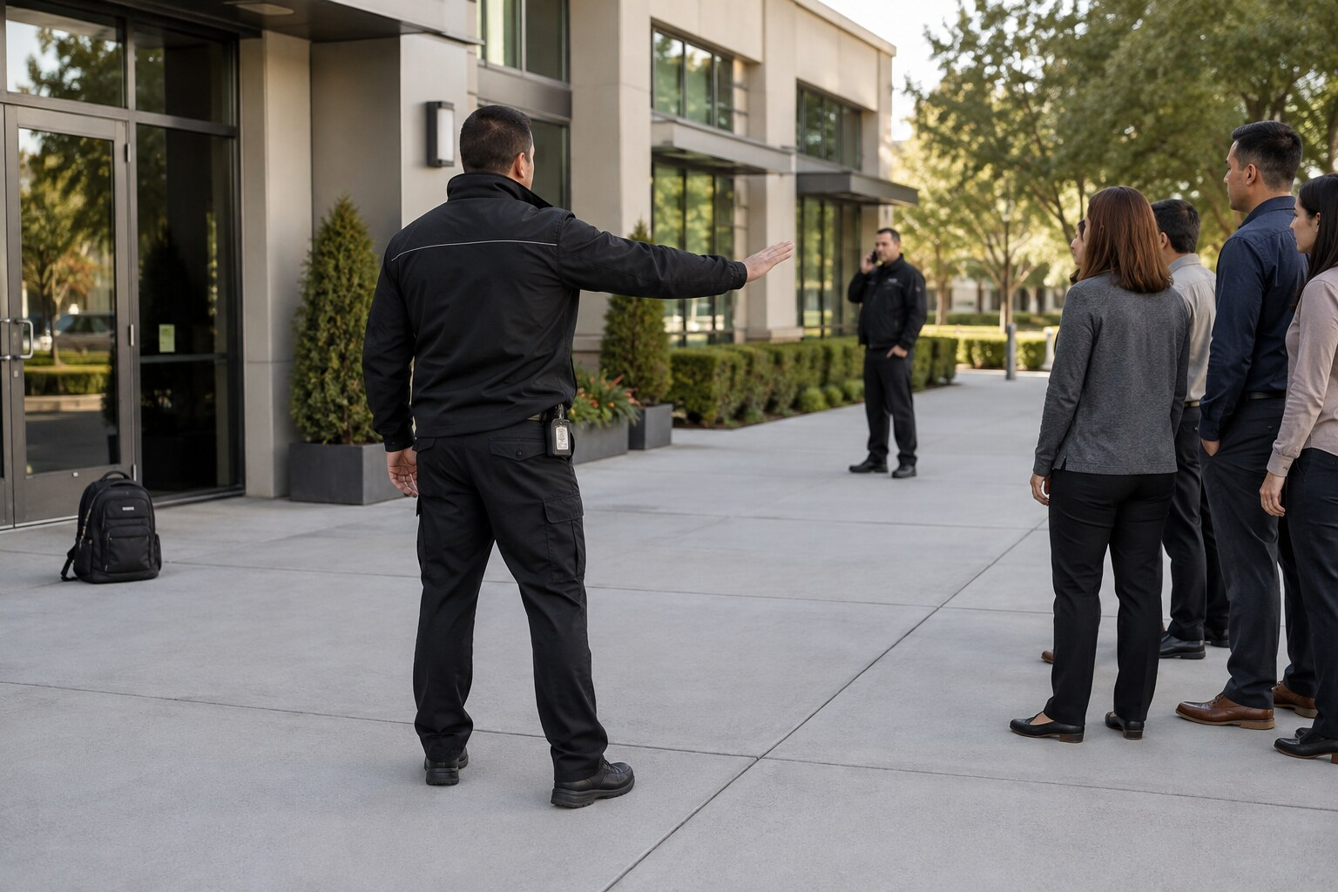
Training visual: maintain distance, redirect people and notify control.
LEARNER TASK
- Place the immediate life-safety actions in the correct order.
- State what must not be done by unqualified personnel.
- Prepare a concise notification and identify observations for the later report.
MODEL RESPONSE
- Prevent anyone from touching, moving, opening, covering or closely examining the article.
- Create distance, direct people through the approved safe route and control access without unnecessary approach.
- Notify control, the supervisor and emergency services through approved channels, following restrictions on radio or phone use near the object.
- From a safe position, record the exact location, appearance, time found, nearby activity, witnesses, actions and instructions received.
ASSESSMENT EVIDENCE
- Life safety and distance take priority over property and convenience.
- The learner does not attempt to render the article harmless.
- Information is concise, objective and suitable for specialist response.
Online reflection: How should crowd-control actions change if the normal exit passes close to the object?

PRACTICAL SCENARIO 9: Break-in indicators discovered during patrol
Learning Unit 3 | Workplace practice and online-learning activity
Situation: At 22:15, an officer finds a rear access door open, fresh marks near the lock and a failed perimeter light. No authorised work is recorded. A person without confirmed authority is walking away from the area.
LEARNER TASK
- Conduct a dynamic risk assessment and state the first radio report.
- Explain containment, backup and safe contact with the person.
- Identify possible evidence and the key occurrence-book facts.
MODEL RESPONSE
- Stop at a safe observation point, use cover, avoid entering alone and report location, observations, direction of travel and immediate hazards.
- Request backup and supervisor support, control access and follow the approved incident or intrusion procedure.
- Address the person only when safe and lawful, separating identity from authority and avoiding unsafe pursuit outside the officer's role.
- Protect the door, tool marks, footprints, video and access records; record times, descriptions, communications, arrivals and handover.
ASSESSMENT EVIDENCE
- The learner does not create a second victim or contaminate the scene.
- Person and vehicle descriptions are objective and uncertainty is stated.
- The record supports investigation, risk control and corrective action.
Online reflection: Which observation is a fact, which is an inference, and which still requires verification?

PRACTICAL SCENARIO 10: Power failure and a suspicious help-desk call
Learning Unit 3 | Workplace practice and online-learning activity
Situation: A power interruption places the access-control system on backup. A caller claiming to be from technical support asks the control room to read out a system identifier and disable an alarm zone so remote repairs can begin. The caller's number is unfamiliar.
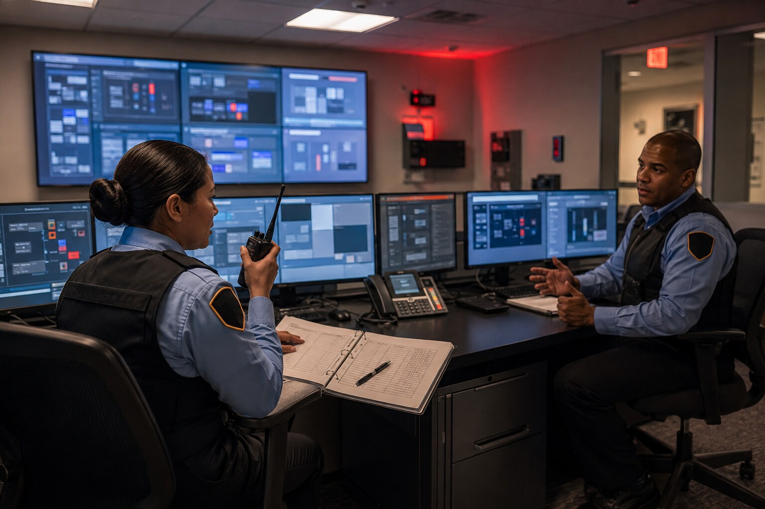
Training visual: use approved contingency records during a system disruption.
LEARNER TASK
- Identify the physical-security, information-security and continuity risks.
- Explain how to verify the caller without using contact details supplied by the caller.
- State the temporary controls, notifications and records required.
MODEL RESPONSE
- Do not disclose identifiers, credentials, alarm configuration or protected operating information and do not change systems on an unverified request.
- Use the approved supplier or internal directory to contact the authorised technical function and verify the work request and change authority.
- Apply the approved outage procedure: manual verification, controlled registers, additional staffing or patrols and clear handovers as authorised.
- Preserve caller details and system logs, notify security management or the information-security contact, and record decisions and restoration checks.
ASSESSMENT EVIDENCE
- The learner recognises social engineering during operational disruption.
- Continuity controls preserve safety and an auditable access record.
- System restoration is verified before temporary measures end.
Online reflection: Why do urgency and technical language make impersonation more convincing?

PRACTICAL SCENARIO 11: Bribe offer and request to alter a register
Learning Unit 4 | Workplace practice and online-learning activity
Situation: A regular delivery driver offers an officer cash to avoid a vehicle check and says everyone saves time this way. Later, a colleague asks the officer to change the occurrence-book time so the delay will not attract management attention.
LEARNER TASK
- Classify the conduct as poor practice, suspected misconduct, possible offence or more than one.
- State the immediate response to the offer and the record-alteration request.
- Identify evidence, confidential escalation and fair-process requirements.
MODEL RESPONSE
- Refuse the benefit, maintain the approved control and do not argue, threaten or create an unsafe confrontation.
- Do not alter, erase or backdate the occurrence record; correct any genuine error transparently under the record-control procedure.
- Report both approaches through the authorised confidential channel and preserve relevant video, messages, witness details and records.
- Separate urgent access or credential restrictions from the disciplinary investigation and any criminal referral; do not predetermine guilt.
ASSESSMENT EVIDENCE
- Integrity is maintained and the access control is not bypassed.
- Evidence is preserved without coordinating accounts.
- The response respects confidentiality and fair procedure.
Online reflection: What should be recorded if refusing the bribe creates an immediate safety concern?

PRACTICAL SCENARIO 12: Possible insider disclosure and confidential reporting
Learning Unit 4 | Workplace practice and online-learning activity
Situation: An officer sees a colleague photograph an access-control panel and send the image through a personal messaging application. The colleague says it is only for a technician and asks the officer not to create trouble by reporting it.

Training visual: discreetly report suspected misconduct through an authorised channel.
LEARNER TASK
- Identify the protected-information and insider-risk indicators without assuming guilt.
- Explain the safest immediate action and confidential reporting route.
- State what evidence should be preserved and what must not be copied or shared further.
MODEL RESPONSE
- Do not accuse or conduct an unauthorised search; protect immediate access and information risks within current instructions.
- Report promptly to the authorised security manager or confidential channel and request guidance on credential or device controls.
- Record only facts personally observed, including time, location, device, words used and persons notified; identify available system or video records.
- Do not forward the image, repeat rumours or discuss the allegation with unauthorised colleagues; preserve evidence through authorised processes.
ASSESSMENT EVIDENCE
- The learner recognises a possible insider indicator and avoids prejudgment.
- Protected information is not amplified during reporting.
- Operational protection, evidence preservation and fair process remain separate but coordinated.
Online reflection: How can the organisation encourage early reporting without creating a culture of accusation?

CORE PRACTICAL ASSESSMENT AND EVIDENCE MAP
Use this map for core Scenarios 1-12. Select role-plays, online responses and workplace observations. The assessor must apply the provider-approved assessment instrument and retain the evidence reference.
Scenarios | Outcome focus | Suggested evidence | Decision standard
1-2 | Outcome 1: Minister/owner functions | Governance explanation; controlled-update record | Authority, ownership and escalation are correct
3-5 | Outcome 2: recruitment and training | Appointment decision; restricted-duty plan; reassessment record | Privacy, suitability and competence controls are applied
6-10 | Outcome 3: responsibilities and limits | Role-play; radio report; occurrence-book or incident entry | Lawful authority, safety, dignity and evidence are protected
11-12 | Outcome 4: prohibited conduct | Classification; confidential report; evidence-preservation plan | No prejudgment; operational risk and fair process are addressed

Assessor evidence checklist
- Learner identifies the current authority and recognises its limits.
- Actions protect life, dignity, information, property and possible evidence.
- Communication is clear, respectful, concise and suitable for the audience.
- Escalation uses an authorised route and is timely for the level of risk.
- Records separate observed fact, information received, inference, decision and outcome.
- Further evidence is required when a model response is memorised but cannot be applied in role-play or workplace observation.

EDITION 4.1 ADVANCED PRACTICE AND FACILITATION PACK
This digital-first pack extends the twelve core scenarios with eight advanced scenarios, five guided skill stations, an online-learning pathway and assessment tools. All sites, people and records are fictional. Learners must never insert real protected-site layouts, codes, vulnerabilities or response details.

How the advanced pack improves competence
- requires the learner to make and justify a decision before seeing the model response;
- adds role allocation, communication practice, record-writing and evidence requirements;
- covers severe weather, drones, credential loss, social engineering, de-escalation, digital evidence, handover and infrastructure tampering;
- supports print-light delivery by keeping advanced activities in the online or facilitator-selected portion; and
- uses generic training situations so operational security is protected.
Control rule: Apply the current law, site plan, post order and authorised instruction. A model answer is guidance for learning, not a substitute for lawful authority or competent assessment.

PRACTICAL SCENARIO 13: Unidentified drone observed near the site boundary
Learning Units 1 and 3 | Advanced role-play and online-learning activity
Situation: During an afternoon patrol, an officer sees a small drone repeatedly hovering outside a generic site boundary. Its operator is not visible. No prohibited item has been dropped and there is no confirmed attempt to enter the site.

Training visual: observe safely, report objectively and avoid unauthorised interference.
ROLE-PLAY ROLES
Patrol officer | Control-room operator | Security supervisor
LEARNER TASK
- Separate observable facts from assumptions about the operator's purpose.
- State the safe observation, notification and information-protection actions.
- Prepare the first report and identify what must not be attempted by untrained staff.
MODEL RESPONSE
- Observe from a safe lawful position; note time, direction, altitude estimate, movement, duration and any visible features without leaving the assigned area.
- Notify control and the authorised supervisor through the approved channel; apply the current site procedure and request police or other authorised support when the assessed risk requires it.
- Do not chase, capture, interfere with or attempt to disable the drone unless a specific lawful authority, approved procedure and trained capability exist.
- Protect operational information: do not post the sighting online or expose camera coverage, patrol patterns or sensitive areas while reporting.
- Record observations, persons notified, instructions, subsequent sightings and the final handover or closure decision.
ASSESSMENT EVIDENCE
- The learner avoids inventing powers or assuming hostile intent.
- The report is objective, time-linked and useful to an authorised decision-maker.
- The response protects people and information without revealing site vulnerabilities.
Online reflection: Which details are useful for identification without disclosing protected operational information?

PRACTICAL SCENARIO 14: Severe rain makes the normal evacuation route unsafe
Learning Units 1 and 3 | Advanced role-play and online-learning activity
Situation: Heavy rain causes local flooding across the normal pedestrian evacuation route. An alarm requires part of a fictional campus to evacuate, but several people begin walking toward the waterlogged route because it is the route they know.
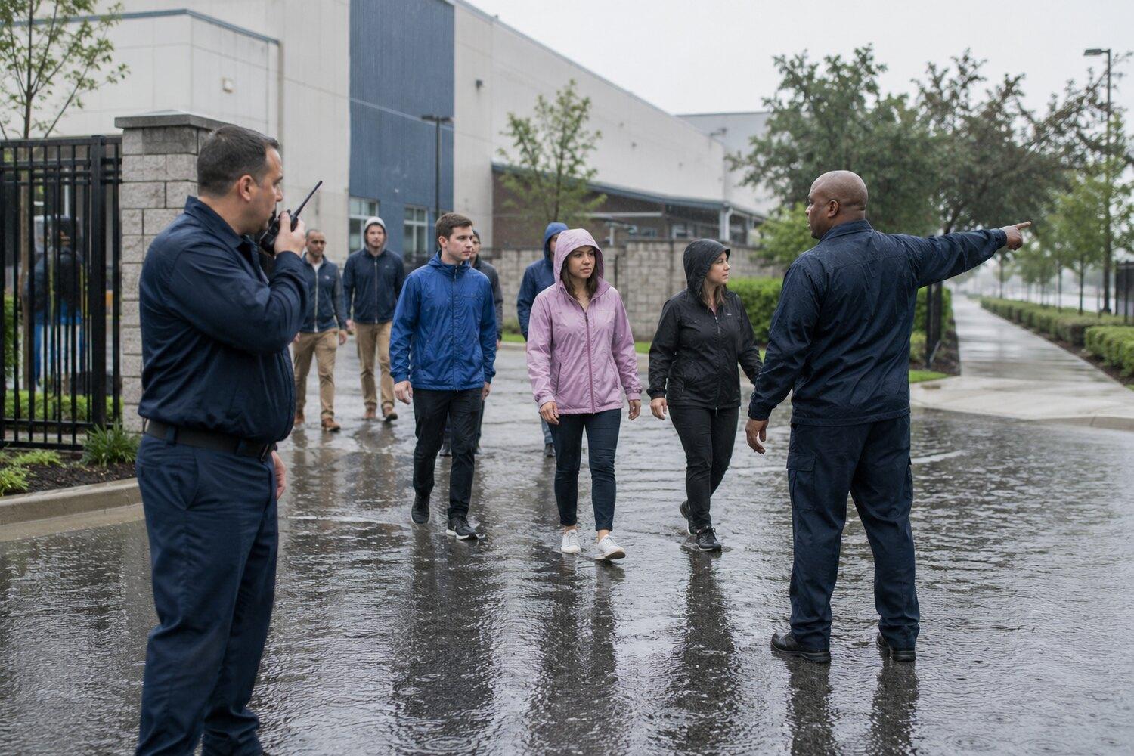
Training visual: redirect people from a route made unsafe by severe weather.
ROLE-PLAY ROLES
Access officer | Control-room operator | Evacuation marshal
LEARNER TASK
- Set the immediate life-safety priorities and define who may change the route.
- Give a concise radio report and clear public instruction.
- Explain how access security, accountability and post-incident records continue during evacuation.
MODEL RESPONSE
- Prevent entry into the unsafe area and direct people to the approved alternative route; never require anyone to cross moving or uncertain-depth water.
- Notify control of the blocked route, exact safe access point, people affected and support required; obtain confirmation of the temporary route from the authorised emergency structure.
- Use calm, repeated instructions and reasonable assistance for persons who need support, without causing crowding at the control point.
- Maintain essential perimeter and access controls unless the emergency plan directs otherwise; do not create informal shortcuts through restricted areas.
- Complete roll-call, outstanding-person, route-change and incident records, and link corrective action to the emergency-plan review.
ASSESSMENT EVIDENCE
- Life safety takes priority while lawful control is maintained.
- The changed route is authorised, communicated and recorded.
- The learner includes assistance, accountability and recovery actions.
Online reflection: What information would allow control to decide whether more staff or emergency services are needed?

PRACTICAL SCENARIO 15: Lost credential followed by an attempted tailgate
Learning Units 2 and 3 | Advanced role-play and online-learning activity
Situation: An employee reports a lost access card. Minutes later, a person in similar clothing asks a colleague to hold a controlled door open, saying the card was left at home and an urgent meeting has started.
ROLE-PLAY ROLES
Security officer | Employee host | Access-control supervisor
LEARNER TASK
- Identify immediate credential and access-control actions.
- Demonstrate a respectful identity-and-authority verification conversation.
- List the electronic and written records that should be preserved.
MODEL RESPONSE
- Keep the door controlled and prevent tailgating without physical confrontation; explain that familiarity or urgency cannot replace verification.
- Report and disable or suspend the missing credential through the authorised process, noting the effective time and decision-maker.
- Verify the person's identity and current access authority through approved records and a trusted contact method, not through information supplied only by the person.
- If temporary access is authorised, apply the approved credential, escort, area and time limits and communicate them clearly.
- Preserve access logs, relevant video references, the lost-card report, verification result, access decision and final credential disposition.
ASSESSMENT EVIDENCE
- No access is granted solely on appearance, status or urgency.
- The missing credential and attempted access are linked in the audit trail.
- The response remains respectful and non-discriminatory.
Online reflection: Why must the missing-card time be recorded accurately?

PRACTICAL SCENARIO 16: Caller claims emergency technical authority
Learning Units 3 and 4 | Advanced role-play and online-learning activity
Situation: During a system fault, a caller claims to be from technical support and says a safety manager has approved urgent remote work. The caller asks for an alarm identifier, controller details and temporary disabling of a protective function.
ROLE-PLAY ROLES
Control-room officer | Caller | Duty supervisor
LEARNER TASK
- Identify the social-engineering indicators and protected information.
- State a safe verification and continuity response.
- Explain what digital and physical evidence should be preserved.
MODEL RESPONSE
- Do not disclose system details, credentials, identifiers or operational configuration and do not alter protective settings on an incoming caller's instruction.
- Use a separately verified service contact and approved change-authorisation process to confirm identity, scope, timing and decision-maker.
- Apply the approved manual or degraded-mode procedure, request additional patrol or access support if required and communicate only the minimum operational information.
- Preserve the call time, number displayed, words used, requested action, verification attempts, system alerts and related occurrence or help-desk references.
- Escalate suspected fraud, attempted unauthorised access or cybercrime through the authorised incident route; security staff preserve and report rather than conduct an unauthorised investigation.
ASSESSMENT EVIDENCE
- The learner verifies through an independent channel.
- Continuity controls remain active during the fault.
- The record supports both operational and technical review.
Online reflection: Which details may be shared with verified support, and who authorises that disclosure?

PRACTICAL SCENARIO 17: Visitor becomes verbally aggressive after access is refused
Learning Unit 3 | Advanced role-play and online-learning activity
Situation: A visitor's appointment cannot be confirmed. The visitor raises their voice, moves closer to the desk and accuses the officer of discrimination. Other visitors begin watching and recording on phones.

Training visual: calm communication, safe distance and early support.
ROLE-PLAY ROLES
Access officer | Visitor | Supervisor or witness officer
LEARNER TASK
- Demonstrate a dignity-based de-escalation conversation.
- State the safety threshold for requesting support or changing position.
- Prepare an objective record that avoids labels and unsupported conclusions.
MODEL RESPONSE
- Maintain safe distance and an open posture, use a calm tone and state the access requirement and available next step without arguing about motive.
- Ask one clear question at a time, acknowledge the concern without admitting facts not established and offer the approved host-verification or complaint route.
- Position yourself so that an exit and assistance remain available; request a supervisor or additional officer early if proximity, threats, crowding or behaviour increases risk.
- Use only lawful, necessary and proportionate measures if immediate safety requires intervention; stop restrictions when the need ends.
- Record exact words or actions where material, distances and movements observed, assistance requested, instructions given and outcome; do not use insulting or diagnostic labels.
ASSESSMENT EVIDENCE
- The learner communicates the rule and options clearly.
- Safety measures are proportionate to observed behaviour.
- The report distinguishes allegation, observation and decision.
Online reflection: What could the officer say to explain the rule without escalating the disagreement?

PRACTICAL SCENARIO 18: CCTV clip is shared through an unauthorised messaging group
Learning Unit 4 | Advanced role-play and online-learning activity
Situation: A short clip showing a security incident is forwarded to officers through a private messaging group. The sender says it will help identify a person. The original export source, authorisation and retention status are unknown.
ROLE-PLAY ROLES
Receiving officer | Control-room custodian | Security manager
LEARNER TASK
- Identify the confidentiality, privacy and evidence risks.
- State what the receiving officer should do without spreading the clip further.
- Describe the authorised preservation and disclosure record.
MODEL RESPONSE
- Do not forward, edit, annotate or publish the clip and do not use an uncontrolled copy as the sole basis for operational action.
- Report receipt confidentially to the authorised manager or information custodian and preserve the message details without unnecessary further copying.
- Ask the authorised system custodian to preserve the original recording, export log, date and time basis, camera reference, access history and retention hold under the approved process.
- Limit viewing and disclosure to authorised persons with a lawful operational purpose; use the minimum necessary information and an approved transfer channel.
- Record who supplied, received, accessed, preserved and transferred the material, plus any instruction, incident reference and final disposition.
ASSESSMENT EVIDENCE
- The learner protects privacy and the integrity of the original record.
- Unauthorised circulation stops without destroying evidence.
- Disclosure is purpose-limited and auditable.
Online reflection: Why can a useful-looking clip still be unreliable evidence?

PRACTICAL SCENARIO 19: Incomplete shift handover leaves unresolved risks
Learning Units 1, 2 and 3 | Advanced role-play and online-learning activity
Situation: At shift change, the outgoing team reports a recurring alarm fault, a radio with a weak battery and a key-pouch count that has not been reconciled. The occurrence book contains brief notes but no owner, due time or escalation reference.
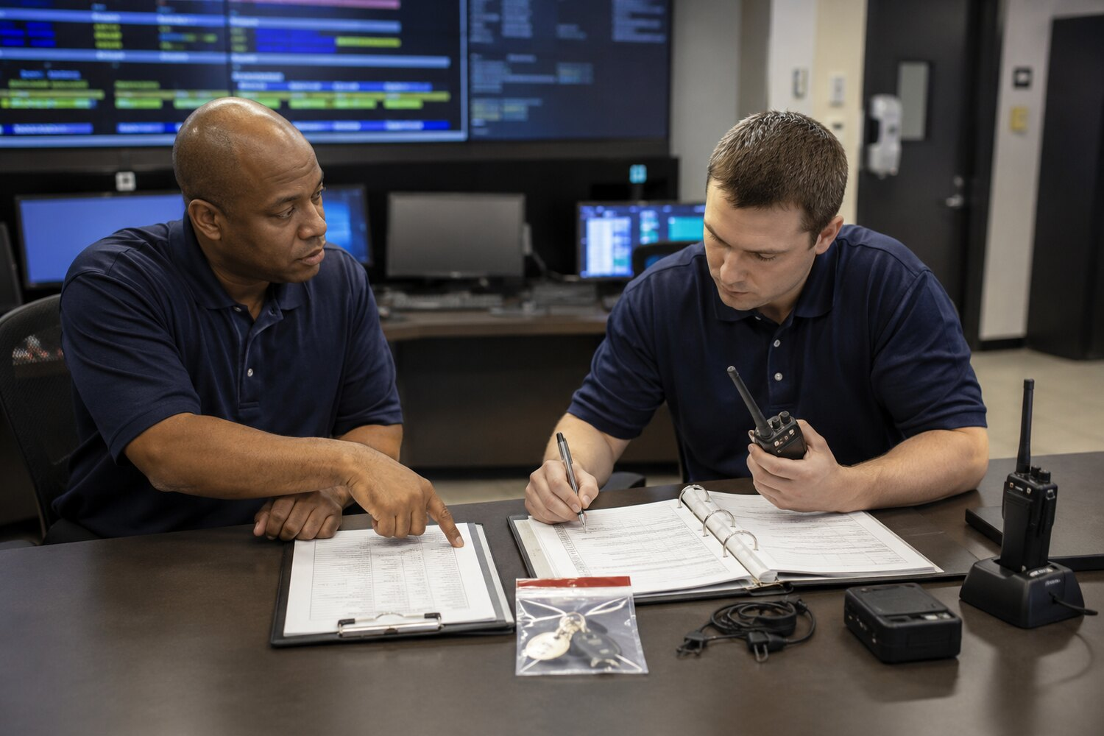
Training visual: verify records, keys, radios and unresolved actions at handover.
ROLE-PLAY ROLES
Outgoing officer | Incoming officer | Shift supervisor
LEARNER TASK
- Conduct a structured handover and identify what cannot be accepted as complete.
- Assign immediate controls, owners and escalation times.
- Complete the records needed for accountability and later closure.
MODEL RESPONSE
- Verify staffing, post status, access restrictions, open incidents, keys, credentials, radios, protective systems and pending visitors or contractors against the controlled handover checklist.
- Treat the key discrepancy as unresolved until reconciled or escalated; apply the approved restriction, search and replacement-control process without altering records.
- Place the weak radio on charge or replace it through the equipment register and confirm that every post retains an effective communication method.
- Apply the authorised contingency for the alarm fault, link the fault and incident references and assign a named owner, priority, due time and review point.
- Both officers and the supervisor record the status accepted, exceptions, controls, notifications and items requiring follow-up; closure requires evidence, not only a signature.
ASSESSMENT EVIDENCE
- The learner verifies rather than merely receives a verbal handover.
- Every exception has a control, owner and review time.
- Equipment and key accountability are traceable.
Online reflection: Which unresolved item creates the greatest immediate risk, and why?

PRACTICAL SCENARIO 20: Possible cable tampering and service disruption
Learning Units 3 and 4 | Advanced role-play and online-learning activity
Situation: During patrol after a local power interruption, an officer sees a damaged service-box cover, fresh tool marks and cut cable near an external boundary. An unfamiliar vehicle is moving away, but no person is currently at the damaged point.
ROLE-PLAY ROLES
Patrol officer | Control-room operator | Police or technical liaison
LEARNER TASK
- Set the safety perimeter and decide what must not be touched.
- Give a concise report without pursuing or confronting the vehicle.
- Identify evidence, continuity and external-notification records.
MODEL RESPONSE
- Assume electrical, fire or other technical danger until a qualified person confirms safety; keep people away and do not handle cables, covers or tools.
- Notify control with the exact generic location, hazards, observed damage, vehicle description and direction of travel; do not leave the assigned duty to pursue.
- Request police, emergency or authorised technical response through the approved plan and implement power-loss, access and communications contingencies.
- Protect the wider scene and likely approach or departure paths from contamination; preserve authorised video, access, alarm and maintenance references.
- Record observations, times, notifications, instructions, service impact, evidence handover and corrective-action owner while avoiding unsupported claims about identity or offence.
ASSESSMENT EVIDENCE
- Technical danger is controlled before evidence handling.
- The learner reports useful vehicle facts without unsafe pursuit.
- Operational continuity and evidence preservation are coordinated.
Online reflection: What facts may be reported immediately even though criminal intent has not been proved?

SKILL STATION 1: Pre-shift readiness and controlled briefing
Objective: Demonstrate that the officer, post, information, equipment and unresolved risks are ready before duty begins.
PROCEDURE
- Confirm current appointment, post allocation, fitness for duty and required licence or credential status.
- Verify the controlled post order, security-plan extract, temporary instructions and effective dates; remove or report obsolete copies.
- Receive a structured handover covering open incidents, access restrictions, visitors, contractors, keys, systems, patrol exceptions and escalation points.
- Function-check the radio, panic or duress device, torch, protective equipment and recording tools without exposing codes or sensitive settings.
- Record defects, temporary controls, owner and review time; do not accept a post when a critical control is absent and no authorised contingency exists.
PRACTICE ACTIVITY
- Facilitator provides three defects: one equipment defect, one outdated instruction and one unresolved incident.
- Learner gives a two-minute briefing-back and states whether the post is ready, ready with restrictions or not ready.
- A peer challenges one decision; the learner must identify the authority and evidence supporting the response.
EVIDENCE TO RETAIN
- Completed readiness checklist
- Defect and escalation record
- Facilitator observation and feedback
Readiness item | Check | Defect / restriction | Owner and review
Officer and appointment | Verified / not verified
Controlled instructions | Current / conflict found
Handover and open risks | Complete / incomplete
Keys, credentials and systems | Reconciled / exception
Communication and equipment | Serviceable / defective

SKILL STATION 2: Access-control conversation and decision record
Objective: Apply identity, authority and access conditions while maintaining dignity and a complete audit trail.
PROCEDURE
- State your role and the applicable access requirement in plain language.
- Ask for identity and purpose, then separately verify appointment, authority, area and time conditions.
- Use an approved independent contact or system; do not rely only on information supplied by the visitor.
- Decide: grant, grant with conditions, delay, refuse or refer. Explain the next approved step without arguing or making threats.
- Escalate when authority, behaviour, information or risk changes, then record the facts, verification, decision and outcome.
PRACTICE ACTIVITY
- Role-play a contractor who is known to staff but absent from the appointment list.
- Repeat the role-play with a language barrier or hearing difficulty and provide reasonable communication support.
- Write a six-line occurrence-book entry that separates observation, information received and the final decision.
EVIDENCE TO RETAIN
- Role-play observation sheet
- Occurrence-book entry
- Feedback and corrected entry
Communication purpose | Useful wording
Explain the requirement | Access can be granted after I confirm your current appointment and area authorisation.
Acknowledge urgency | I understand the matter is urgent. I will keep the verification moving and update you on the next step.
Refuse without accusation | I cannot confirm authority at present, so I cannot grant access. The approved next step is ...
Request support | Control, please send the supervisor to the reception point. Access remains controlled and there is no immediate injury.

Training visual: verify identity and authority before making an access decision.

SKILL STATION 3: Initial radio report and incident update
Objective: Give a concise report that lets control understand the location, hazard, people, actions and support required.
PROCEDURE
- Prepare before transmitting: identify the channel, call sign, urgency and minimum information required.
- State the exact approved location reference and immediate hazard first.
- Report only observed facts and clearly attribute information received from another person.
- State people affected, actions already taken and the specific support or decision required.
- Listen for read-back or instruction, confirm critical details and record the transmission time and outcome.
PRACTICE ACTIVITY
- Give a 30-second initial report for Scenario 14, 17 or 20.
- After the facilitator changes one fact, give a short update without repeating irrelevant information.
- Write the matching occurrence-book entry and compare it with the audio or facilitator notes.
EVIDENCE TO RETAIN
- Initial report checklist
- Update message
- Matching occurrence-book entry
Model structure: LOCATION - HAZARD - PEOPLE - ACTIONS - SUPPORT - CONFIRMATION.

Training visual: give a concise radio report while a second officer records key facts.

SKILL STATION 4: Incident report - fact, source and inference
Objective: Produce a fair, chronological report that another authorised person can understand and verify.
PROCEDURE
- Write the date, time, location, assignment and how the incident came to your attention.
- Record what you directly saw, heard or did in chronological order using neutral language.
- Attribute information from others by naming or describing the authorised source and recording the words accurately where material.
- Label any inference or assessment and state the facts supporting it; do not present suspicion as proved fact.
- Record instructions, decisions, notifications, evidence references, outcome and outstanding action. Correct errors transparently; never erase, overwrite or backdate.
PRACTICE ACTIVITY
- Rewrite this weak sentence: 'The suspicious thief tried to break in and was obviously dangerous.'
- Use the Scenario 17 or 20 facts to produce a 150-word report.
- Peer-review the report for unsupported labels, missing times, passive wording and unexplained conclusions.
EVIDENCE TO RETAIN
- First draft
- Peer feedback
- Corrected final report with transparent amendment
Improved example: At 21:12 I observed an unknown person pull the north service-door handle twice. The door remained closed. I asked the person to step back and state their purpose. The person moved away toward the public road. I notified control at 21:13 and recorded the clothing and direction of travel.

Training visual: distinguish direct observation, information from others and clearly labelled inference.

SKILL STATION 5: Evidence preservation and accountable handover
Objective: Protect possible physical or digital evidence without exceeding authority or contaminating the record.
PROCEDURE
- Make the area safe and prevent unnecessary access, handling, viewing, copying or alteration.
- Identify the lawful reason and authorised decision for taking control, preserving a record or refusing access.
- Record the item's or record's original location, condition, identifying features, date, time and person who discovered it.
- Use approved packaging, seals, export procedures and labels only when trained and authorised; never place protected details in a public or general-purpose channel.
- Record every transfer: giver, receiver, date, time, purpose, condition, seal or reference and destination. Obtain acknowledgement and report any break in continuity.
PRACTICE ACTIVITY
- Practise a physical handover using a harmless training object and a digital handover using a fictional video reference.
- Facilitator introduces one discrepancy in a seal, time or recipient; learner must stop and resolve or escalate it.
- Explain why a photograph or copied clip does not automatically replace the original evidence source.
EVIDENCE TO RETAIN
- Evidence or property record
- Transfer acknowledgement
- Discrepancy and corrective-action record
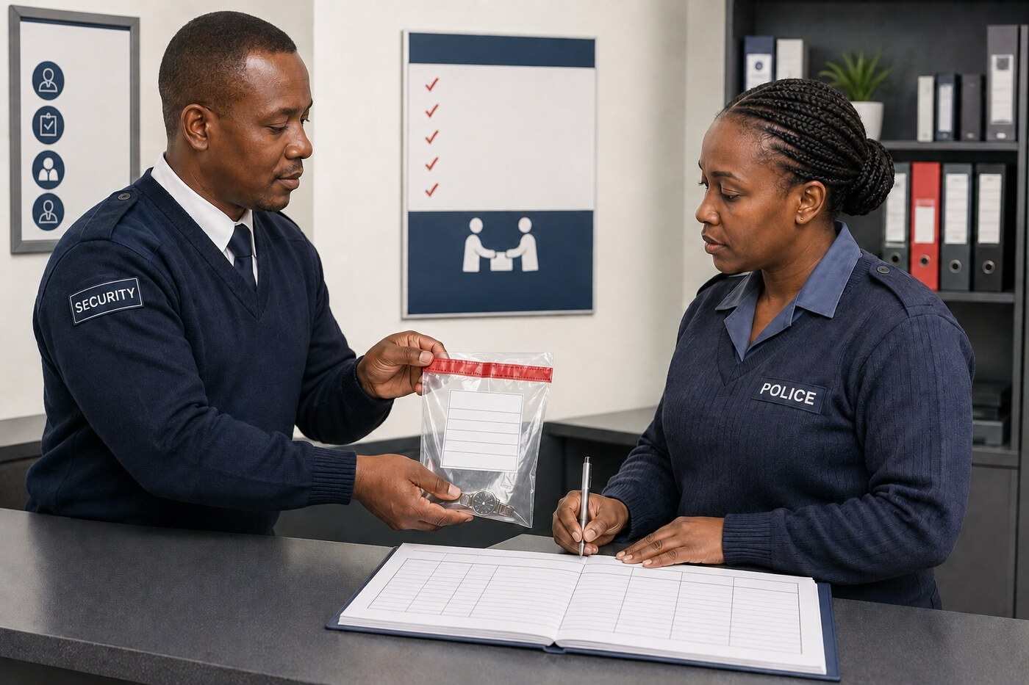
Training visual: verify the seal, record the transfer and obtain acknowledgement at handover.

ONLINE LEARNING PATHWAY AND FACILITATOR GUIDE
Use short learning cycles. The learner must attempt, receive feedback, correct and demonstrate application; completion is not measured only by opening pages or selecting answers.
Stage | Learner action | Facilitator / platform action | Evidence
1. Prepare | Read outcome, authority note and safety limits | Release current source links and fictional scenario | Access or briefing acknowledgement
2. Attempt | Submit decision and first report before model answer | Keep model response hidden | Timestamped first attempt
3. Compare | Identify gaps against the model and site procedure | Give targeted feedback, not only a score | Self-review and feedback
4. Rehearse | Complete role-play, audio report or simulated record | Observe behaviour and record criteria | Observation or recording reference
5. Correct | Resubmit the decision or record | Confirm corrections and remaining risk | Final submission
6. Transfer | Apply to a new scenario without prompts | Assess independent performance | Competence decision

Online security and privacy controls
- Use only fictional site names, plans, persons, contact details, identifiers, images and records in online activities.
- Restrict access to enrolled learners, authorised facilitators and assessors; apply the provider's retention and deletion schedule.
- Do not require learners to upload identity documents, medical information, real occurrence-book pages or protected-site photographs unless a lawful approved process specifically requires and secures them.
- Provide accessible alternatives for images, audio, timed tasks and role-play where reasonable accommodation is required.

PRACTICAL ASSESSMENT RUBRIC
Criterion | Not yet competent | Developing / supported | Competent independently
Authority and limits | Does not identify authority or invents powers | Identifies some authority but needs prompts on limits | Independently identifies current authority, scope and limits
Safety and dignity | Creates avoidable risk or uses disrespectful conduct | Generally safe but misses one safeguard or support need | Protects life, dignity, access and information proportionately
Decision and escalation | Decision is unsupported or escalation is absent | Decision is reasonable with facilitator support | Makes a timely decision and uses the correct authorised escalation
Communication | Message is unclear, accusatory or exposes protected detail | Message is understandable but incomplete | Message is calm, concise, audience-appropriate and secure
Record and evidence | Facts, inference and outcome are confused | Core facts are present but chronology or continuity is incomplete | Record is chronological, attributable, transparent and audit-ready
Transfer to new case | Repeats model wording without application | Applies the model with prompts | Adapts principles independently to a different scenario
Assessment rule: A written answer alone is insufficient where the outcome requires practical scenario training, role-play or observation. Apply the provider-approved assessment instrument and moderation process.

LEARNER PRACTICAL LOGBOOK
Record only fictional or approved training references. Do not reproduce protected operational information in this learner guide.
Date | Scenario / skill | Role performed | Evidence reference | Feedback and correction | Assessor initials

Learner declaration
I confirm that the evidence identified above is my own work or participation, that confidential information has been protected and that corrections requested by the facilitator or assessor have been completed.
Learner name and signature: ______________________________________ Date: __________________
Facilitator / assessor: ___________________________________________ Date: __________________

Digital reference appendices
Online/reference section: These appendices restore important supporting material from the legacy guide in a current, controlled format. They may be omitted from routine print copies and supplied electronically unless the approved delivery or assessment plan requires them in print.

Appendix A: SAQA outcome and criterion map
SAQA outcome | Evidence focus retained in this guide
Outcome 1 | Explain the functions of the Minister and the owner. Evidence must address both roles in relation to current legislation and valid delegation.
Outcome 2 | Explain regulated application information, disqualification, provisional employment and training requirements.
Outcome 3 | Explain responsibilities; unidentified persons; unattended articles; search and seizure; arrest, reasonable and proportional force; and limits of authority.
Outcome 4 | Explain conduct that may lead to disciplinary action and identify prohibited acts or offences under applicable legislation.

Evidence rule
- Use scenarios and role-plays for application, not memorisation alone.
- Assess the learner's ability to state authority, limits, safe action, escalation and records.
- Do not award competence where an answer creates an unlawful power or unsafe practice.
- Record reasonable accommodation and recognition-of-prior-learning arrangements.

Appendix B: Statutory and operational source map
Topic | Sources to verify
Designation and transition | National Key Points Act 102 of 1980; Critical Infrastructure Protection Act 8 of 2019; commencement notices and site-specific designation records.
Governance and safeguarding | Applicable Act and regulations in force; valid directions; approved security policy and security plan.
Employment and professional conduct | Employment law, PSiRA requirements, employer policy, appointment and disciplinary procedures.
Access, search and seizure | Applicable statutory authority, valid consent, contractual access conditions, arrest-related powers and approved site procedures.
Arrest and force | Current Criminal Procedure Act, other applicable legal authority, case law, approved policy and qualified instruction.
Firearms | Current Firearms Control Act and regulations, licence and competence conditions, issue register, employer controls and approved training.
Information and records | Applicable information-protection duties, secrecy or confidentiality provisions, retention schedule and authorised disclosure process.
Emergency response | Approved site emergency plan, responsible public authority instructions and competence-specific procedures.
Control rule: The source map directs verification; it is not a legal opinion and does not replace the official text or site-specific approval.

Appendix C: Owner and security-management checklist
- Current legal status, designation and applicable transition arrangements confirmed.
- Security policy, security plan and post orders approved, version-controlled and communicated.
- Roles, delegations, reporting lines and emergency authority documented.
- Personnel screening, appointment, competence and refresher records current.
- Access, visitor, contractor, key, credential and vehicle controls tested.
- Communications, protective equipment and security systems serviceable and recorded.
- Occurrence books, registers, incident reports and evidence processes controlled.
- SAPS, emergency-service and other authorised liaison details validated.
- Exercises and inspections completed against the approved schedule.
- Deficiencies assigned, risk-rated, tracked and closed with evidence.
- Protected information classified, shared and retained only through authorised channels.
- Legal, regulatory and training changes reviewed before the next programme offering.

Review record
Site / programme
Reviewer and role
Review date
Actions and due dates
Approval / closure

Appendix D: Appointment and deployment checklist
Control | Status / evidence reference
Identity and eligibility | Verified / outstanding / not applicable
PSiRA registration and standing | Verified / outstanding / not applicable
Screening and authorised decision | Approved / restricted / referred
Foundational qualification | Verified / outstanding / not applicable
NKP or applicable programme competence | Completed / in progress / not approved
Site induction and post assessment | Completed / supervised / not approved
Licence or equipment competence | Verified / restricted / not applicable
Written appointment and role limits | Issued / pending / withdrawn
Credential, keys and system access | Issued / restricted / returned
Fitness for duty and briefing | Confirmed / referred / not deployed
Supervisor and review date | Name, signature and date
Deployment decision: Do not deploy a person merely because one document has been produced. The complete role-specific control set must support the decision.

Appendix E: Occurrence-book and incident-record standard

Occurrence-book entry
- Use the next available line or approved electronic sequence; never leave space for later insertion.
- Record date, time, place, person making the entry and objective facts.
- State the action taken, instruction received, notifications and outcome.
- Reference related reports, video, property or evidence records without inserting protected details unnecessarily.
- Correct an error transparently; do not erase, overwrite or backdate.

Incident report structure
Section | Minimum content
What happened | Chronological facts and how the incident was detected.
Who was involved | Verified identities, roles and witness contact references where authorised.
Authority and decisions | Instruction, power, procedure and decision-maker relied upon.
Actions and safety | Access control, emergency action, force, medical care and scene protection.
Evidence and property | Items, images, records, seals, continuity and receiving person.
Notifications | Control, management, SAPS or other authority; times and reference numbers.
Outcome and follow-up | Current status, residual risk, corrective action and responsible owner.

Appendix F: Scenario observation and evidence sheet
Use this sheet for role-play, practical observation or structured online scenario evidence.
Criterion | Observation / evidence
Scenario / learner
Authority identified | Competent / further evidence required — notes:
Limits recognised | Competent / further evidence required — notes:
Safety and dignity | Competent / further evidence required — notes:
Communication | Competent / further evidence required — notes:
Escalation | Competent / further evidence required — notes:
Record and evidence | Competent / further evidence required — notes:
Overall decision | Competent / not yet competent / evidence deferred
Feedback and action
Observer / assessor | Name, signature and date

Feedback principles
- Give specific feedback linked to the outcome and observed behaviour.
- Correct unsafe or unlawful reasoning immediately.
- Record the further practice or evidence required and the review date.

Appendix G: Legacy-content disposition
The expanded edition restores the learning coverage of the legacy guide without reproducing unstable diagrams, obsolete penalty figures or lengthy historical extracts as current instruction.
Legacy content | Treatment in this edition
SAQA outcomes and assessment criteria | Restored as the programme profile, evidence map and assessment guidance.
Definitions and safeguarding structure | Restored as controlled definitions, governance roles and the owner safeguarding system.
Minister and owner duties | Restored as functional summaries with a requirement to verify the current provision.
Application, disqualification and provisional employment | Restored as lawful screening, appointment-file and lifecycle controls.
Training history | Not taught as current authority; retained only as background where a facilitator can verify relevance.
Unidentified persons, articles, search and seizure | Restored as rights-based decision sequences and record standards.
Arrest, force and firearms | Restored as legal decision and reporting principles; practical techniques remain outside this guide.
Summary dismissal, offences and penalties | Restored as misconduct, fair-process and escalation guidance; historic penalty figures excluded.
Legacy diagrams and photographs | Excluded where broken, inaccessible, operationally sensitive or subject to uncertain reproduction rights.
Acknowledgements and copyright notices | Summarised in document control pending written confirmation of reproduction and adaptation rights.
Approval action: Legal and subject-matter reviewers must confirm that each restored summary is suitable for the intended sites and delivery period.

Glossary
Term | Meaning
Authorised | Permitted by current law, a valid appointment, delegation or approved procedure.
Critical infrastructure | Infrastructure considered or declared under the Critical Infrastructure Protection Act framework.
Incident | An occurrence or threat that may adversely affect security, people, information, assets or operations.
National Key Point (NKP) | A place or area declared under the applicable National Key Points legislation.
Necessity | The requirement that an action is genuinely needed to achieve a lawful purpose.
Person in control | The person or entity legally responsible for control of infrastructure under the applicable framework.
Proportionality | The requirement that a restriction or force does not exceed what is reasonably required.
PSiRA | Private Security Industry Regulatory Authority.
SAQA | South African Qualifications Authority.
SAPS | South African Police Service.
Security limit | The formally defined boundary relevant to the site's security controls.
Security manager | The authorised person responsible for coordinating and managing the site's security function.
Control security officer | A designated supervisor responsible for operational control during a shift or defined period.
Site procedure | A current, approved instruction derived from law, policy, risk assessment and the security plan.
Chain of custody | The documented sequence of possession, control, transfer and condition of evidence or property.
Cyber-physical incident | An event where digital systems and physical security, safety or operations affect one another.
Data minimisation | Collecting, using and retaining only the personal information genuinely required for the lawful purpose.
De-escalation | Communication and positioning used to reduce tension and create safe options without unnecessary force.
Tailgating | A person entering a controlled area by following another person without separate authorisation.
Uncrewed aircraft / drone | A remotely or automatically operated aircraft; observe and report under current law and site procedure without inventing interference powers.

Outcome and evidence map
Unit | Outcome | Learning evidence | Assessment evidence
1 | Minister and owner functions | Governance cases; Scenarios 1-2 and 13-14; readiness station | Explanation of responsibilities, resilience controls and escalation
2 | Recruitment, selection and training | Candidate cases; Scenarios 3-5 and 15; readiness station | Controls for appointment, competence, credentials and deployment
3 | Responsibilities, powers and limits | Scenarios 6-10 and 13-17, 19-20; Skill Stations 2-5 | Lawful decision sequence, communication, record and justification
4 | Prohibited acts and offences | Scenarios 11-12 and 16, 18, 20; report and evidence stations | Classification, protected reporting, confidentiality and fair decision

References and source status
Use the current official version of each source. Accessed 19 August 2026.
- SAQA: Unit Standard 246693
- South African Government: National Key Points Act 102 of 1980
- South African Government: Critical Infrastructure Protection Act 8 of 2019
- Government Gazette: commencement of specified sections of Act 8 of 2019
- Government Gazette: draft Critical Infrastructure Protection Regulations published for comment in 2023
- Department of Justice: Criminal Procedure Act 51 of 1977
- SAPS: Firearms Control Act 60 of 2000
- PSiRA: Code of Conduct for Security Service Providers
- Department of Justice: Protection of Personal Information Act 4 of 2013
- South African Government: Cybercrimes Act 19 of 2020 and commencement record
- PSiRA: regulatory mandate and current online services
- PSiRA: Training Division
- SAPS: Government notices, including draft critical-infrastructure regulations

Required approval record
Legal review | Name, signature, professional capacity, date and limitations of review
Subject-matter review | Name, role, organisation, signature and date
Accreditation review | Scope, programme approval reference, reviewer, signature and date
Quality assurance | Version approved, changes required, approval date and next review date
Final control: Do not remove this approval page. Record every legal, regulatory and content update in the provider's controlled document register.

